SPage URL - https://rootcabs.com/business-solutions
Slug Suggestion - https://rootcabs.com/business-solutions
Primary Keyword
Secondary & LSI Keywords

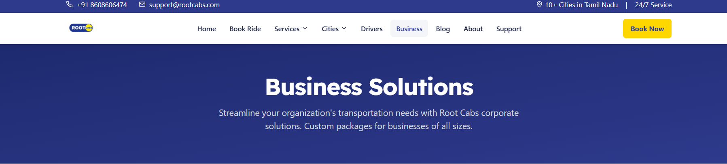

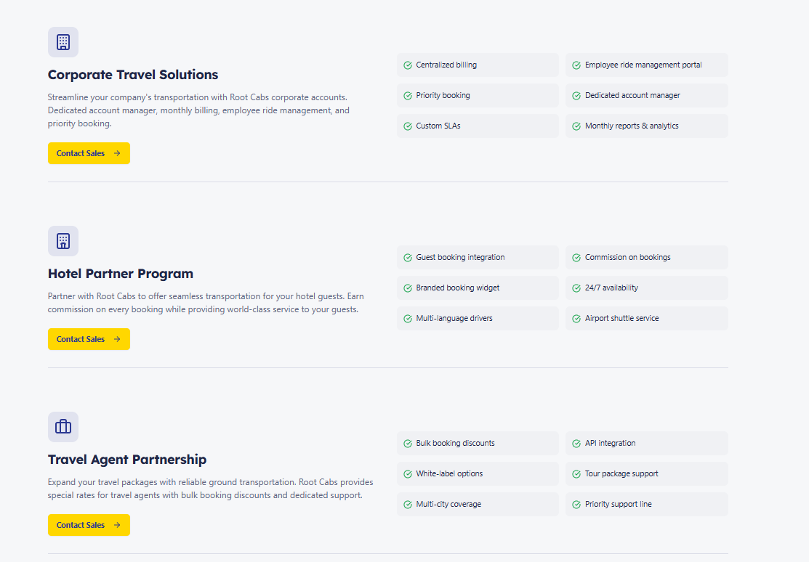

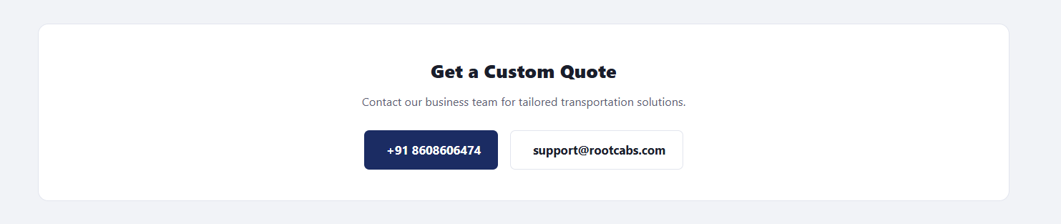

Write like Contact Us
Call Button need to added instead of if user clicks the button it need to be redirected to dial

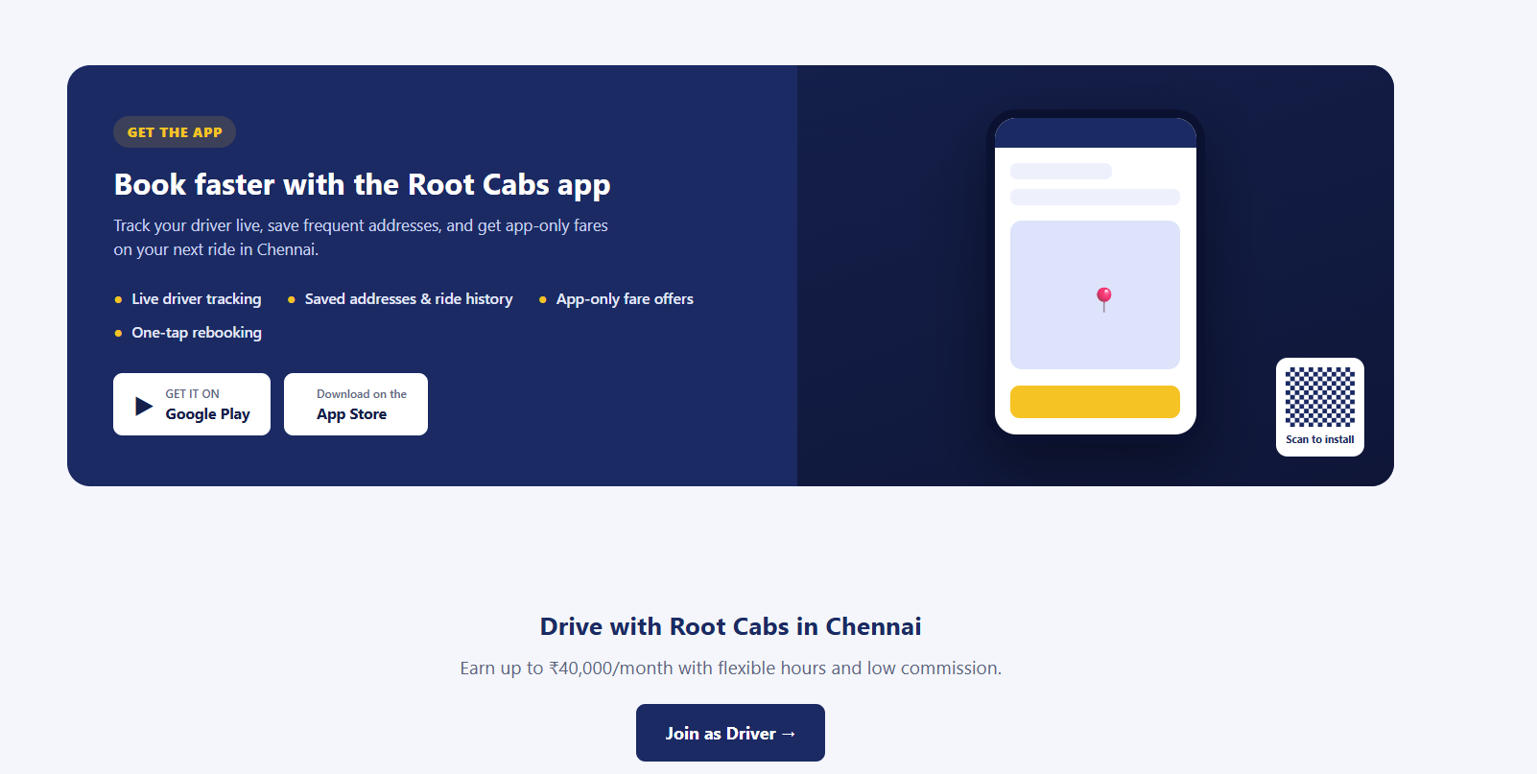

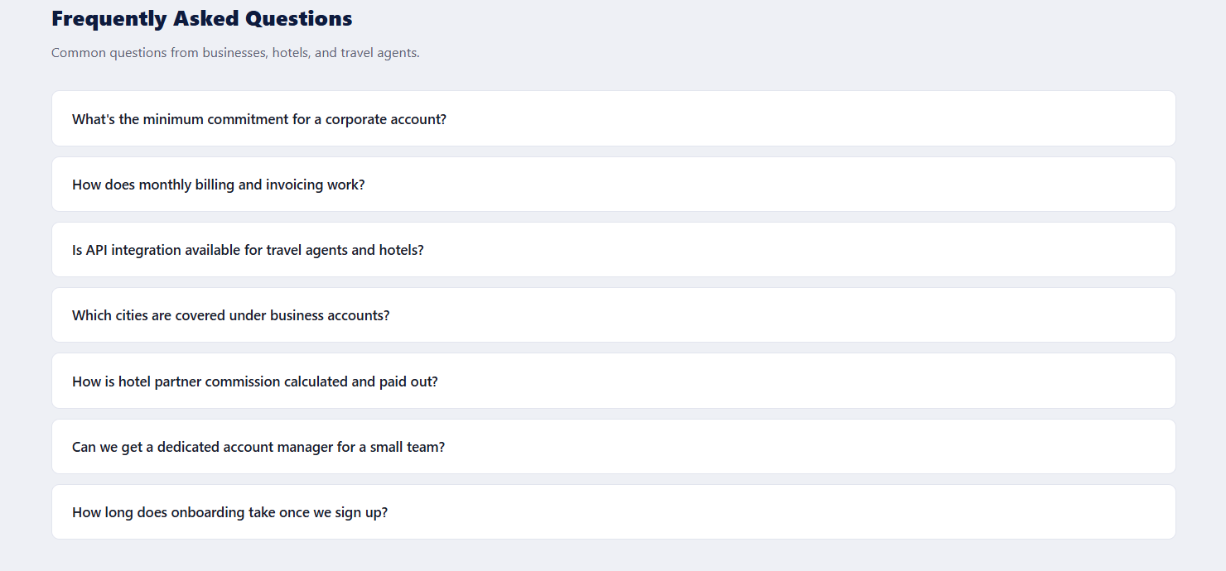

FAQ
Which cities are covered under these business solutions?
Is there a minimum size requirement for a corporate account?
How do I get pricing for my business?
Can travel agents integrate Root Cabs bookings into their own platform?
Is airport shuttle service available as part of the Hotel Partner Program?

